**Aim:** Design a LED flasher.

**Apparatus:** Arduino Board, LED, Resistance - 220ohm.

**Circuit diagram:**

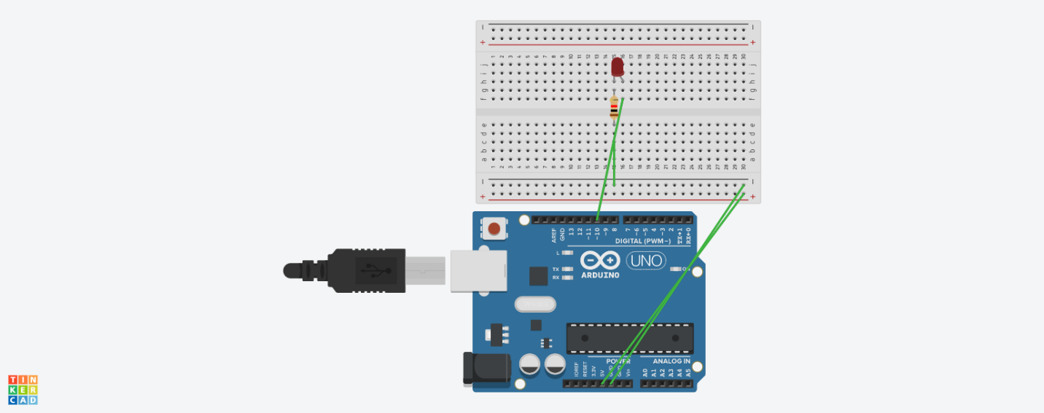

**Theory:**

Led have two sides p and n type. N type have more area than p type.

Arduino uno is a designed hardware used for housing circuit or making the digital circuit in lab easily.

**Observation**:

Blinking of light

Precaution:

1. Insert resistance at p type.
2. Insert wire properly.
3. Ground the n type of led.
4. Write the code properly.